Laboratory work #2 (DataBase)

Nabi Nurdaulet

Normalization:

Task 1: Violation of Normal Forms
The unnormalized table Booking_receipt violates:
- 1NF: The column seat_numbers contains multiple non-atomic values separated by commas (e.g., "12A, 12B").
- 2NF & 3NF: Partial and transitive dependencies exist. Passenger details (passenger_full_name), airport details (departure_city, arrival_city), and airline details (airline_name) depend on non-key attributes instead of directly on the primary key.

Task 2 & 3: Step-by-Step Normalization & Functional Dependencies
- Step 1: 1NF (Atomic Values)
  - Table: Booking_receipt_1NF (booking_id, seat_number, passenger_full_name, passenger_passport_number, flight_number, departure_airport_name, departure_city, arrival_airport_name, arrival_city, airline_name, ticket_price)
  - FD: {booking_id, seat_number} -> {passenger_full_name, passenger_passport_number, flight_number, departure_airport_name, departure_city, arrival_airport_name, arrival_city, airline_name, ticket_price}

- Step 2: 2NF (Removing Partial Dependencies)
  - Table 1: Booking (booking_id, passenger_full_name, passenger_passport_number, flight_number, departure_airport_name, departure_city, arrival_airport_name, arrival_city, airline_name, ticket_price)
    - FD: booking_id ->{passenger_full_name, passenger_passport_number, flight_number, departure_airport_name, departure_city, arrival_airport_name, arrival_city, airline_name, ticket_price}
  - Table 2: Booking_Seat (booking_id, seat_number)
    - FK: booking_id REFERENCES Booking(booking_id)

- Step 3: 3NF (Removing Transitive Dependencies)
  - Passenger (passenger_passport_number, passenger_full_name)
    - FD: passenger_passport_number ->passenger_full_name
  - Airport (airport_name, city)
    - FD: airport_name ->city
  - Flight (flight_number, departure_airport_name, arrival_airport_name, airline_name)
    - FK: departure_airport_name REFERENCES Airport(airport_name)
    - FK: arrival_airport_name REFERENCES Airport(airport_name)
    - FD: flight_number ->{departure_airport_name, arrival_airport_name, airline_name}
  - Booking (booking_id, passenger_passport_number, flight_number, ticket_price)
    - FK: passenger_passport_number REFERENCES Passenger(passenger_passport_number)
    - FK: flight_number REFERENCES Flight(flight_number)
    - FD: booking_id ->{passenger_passport_number, flight_number, ticket_price}
  - Booking_Seat (booking_id, seat_number)
    - FK: booking_id REFERENCES Booking(booking_id)

Task 4: Analysis of the Flights Table
- Primary Key: flight_id
- Functional Dependency: flight_id ->{sch_departure_time, sch_arrival_time, departing_airport_id, arriving_airport_id, departing_gate, arriving_gate, airline_id, act_departure_time, act_arrival_time, created_at, updated_at}
- Is it in 3NF? Yes. All non-key attributes directly depend on the primary key (flight_id). Attributes like departing_airport_id and airline_id are foreign keys and do not create transitive dependencies between non-key attributes.

DDL:

Task 5: Implementation of 3NF Tables & Data Insertion

Below is the SQL script used to create the normalized 3NF tables (Passenger, Airport, Flight, Booking, and Booking_Seat) and populate them with sample data as required.

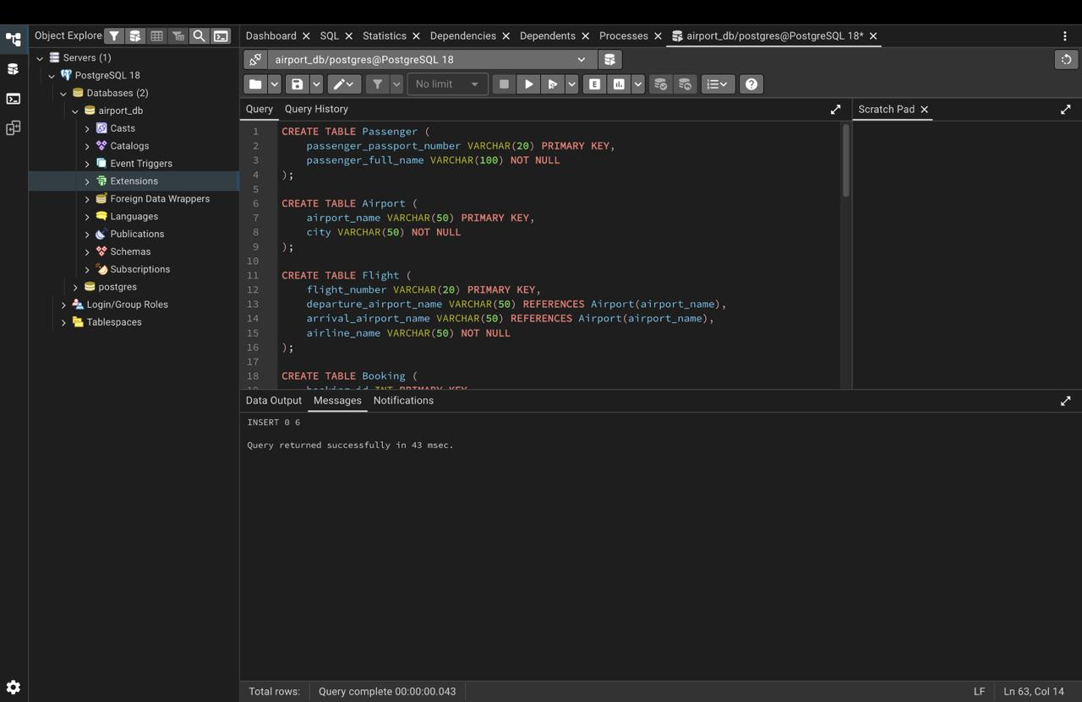
Successful execution of 3NF schema creation and data insertion in pgAdmin.

Section DDL: Data Definition Language

Table Creation Script:
Below is the SQL script used to create the 10 primary tables for the Airport database system (Airline_info, Airport_Info, Passengers, Security_check, Flights, Booking, Booking_flight, Boarding_pass, Baggage, and Baggage_check). Primary keys (PRIMARY KEY), column data types, and mandatory field constraints (NOT NULL) have been defined for each table.

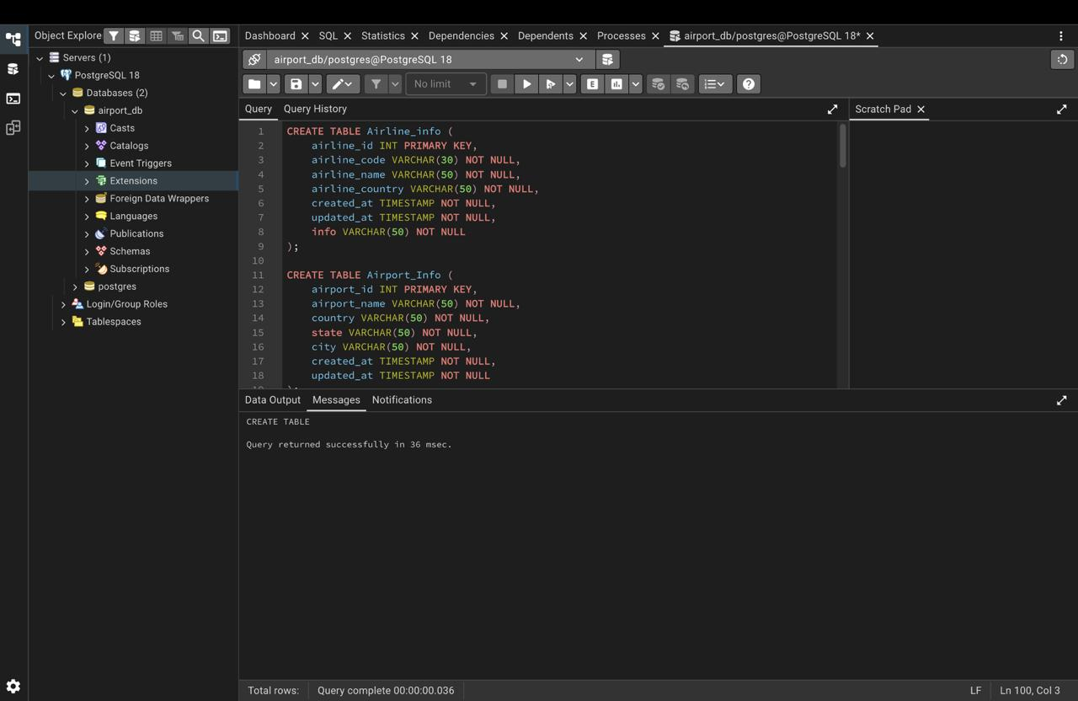
Successful execution of table creation scripts in pgAdmin.

Table Modifications and Foreign Keys

The following script modifies the table structures using ALTER TABLE commands (renaming Airline_info to Airline, renaming column price to ticket_price, changing departing_gate data type to TEXT, and dropping the redundant info column). It also establishes relational integrity across tables by adding explicit FOREIGN KEY constraints.
.
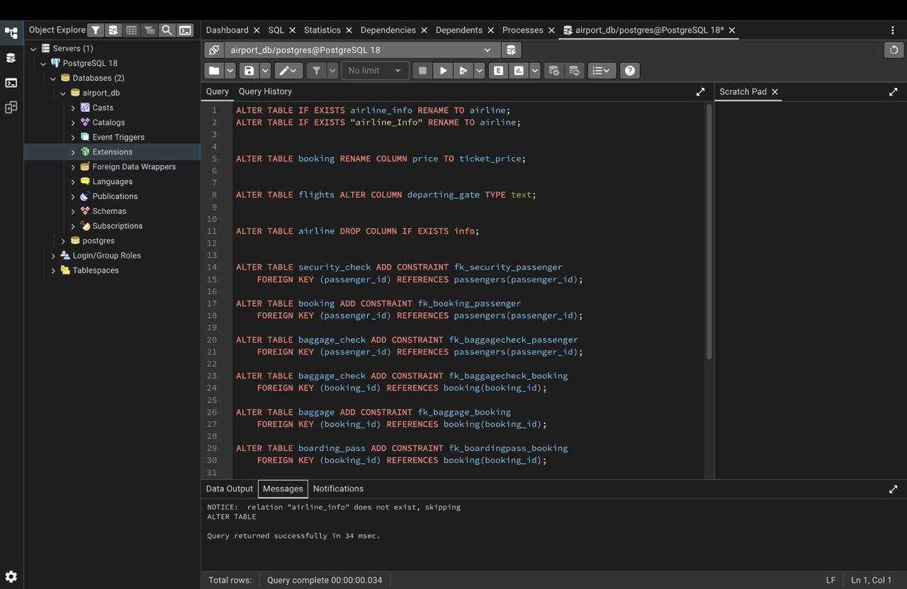
Successful execution of structural modifications and Foreign Key relationships in pgAdmin.

